_______________________________________ 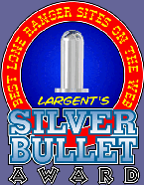

Have Just Been Awarded the Silver Bullet Award for your outstanding ability to Quote Scriptures out of context, misapply them, and use them to make your own point. You have also won the award for the justifying how you are outstandingly right in your thinking that you will not even consider overriding evidence that there is other opinions much more logical and provable than yours.
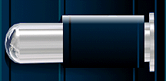 Reason for the Award __________________________
Awards Committee _____________________ Date _______
