United Church of God, an International Association

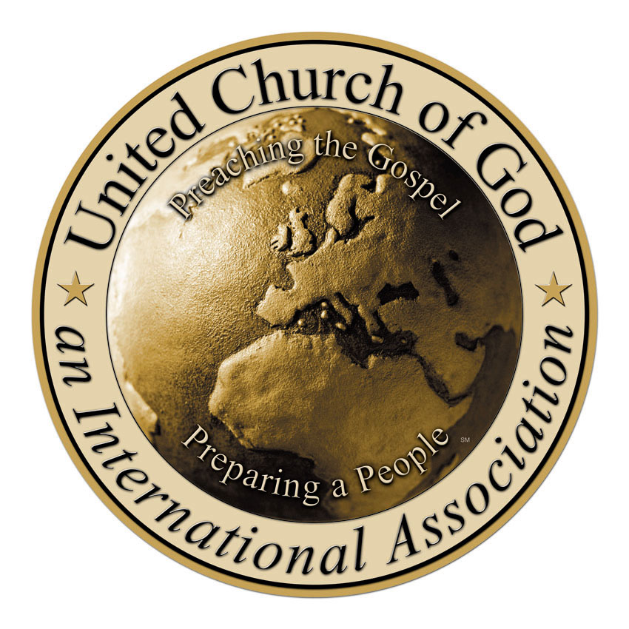
..........

The Hebrew Calendar
Doctrinal Paper

Approved by the Council of Elders
June 1996

All of the inset, but not UCG official, comments are in red. They are in a different color so one will not get confused as the paper is dissected, thought by thought. You will see the red letters are the contrasting thought. It takes away the accepted non-provable assumptions.

All scriptures are quoted from The Holy Bible, New King James Version (© 1988 Thomas Nelson, Inc., Nashville, Tennessee) unless otherwise noted.
The Hebrew Calendar

Questions have arisen in the Church of God regarding the use of the Hebrew Calendar in determining the dates for observance of the annual Holy Days. The questions seem to center around the validity of this calendar for Christians, as well as the validity of the rules of postponement that form the basis for the calendar calculations.

The purpose of this statement is to address the subject in a general way while doctrinal studies continue. There is a desire on the part of the United Church of God, an International Association, to publish more on this subject in the future. This statement consists of material gathered from a variety of sources. We do not intend that this statement be the final word on the subject, but it does reflect our current position.

Several people and organizations have addressed this subject in recent years and have reached various conclusions. There are several interpretations currently being taught by various groups or individuals on this matter. Obviously, they cannot all be correct. We have a desire for unity in the Church of God and for a common gathering of God’s people on the annual Holy Days. It is with this in mind that we present this preliminary statement on the subject of the Hebrew Calendar.

Complexities of the Problem

We begin by pointing out the complexities of the problem. We must take into account the following factors:

- The Bible does not provide us the complete means for calculating a calendar. There are no calculations provided in the Scriptures. The Bible clearly indicates that there were the components of a calendar in existence almost from the beginning: hours, days, months, seasons, and years are all mentioned. These are the essential elements of any calendar.
- Most calendars that are being proposed use the new moon as the beginning of the month. While we would not disagree with this principle, we know of no definitive biblical statement to that effect. We accept the new moon as the beginning of the month, and there are references in the Bible which indicate that the new moon was the beginning of the month. But we know of no clear statement that the calendar is to be calculated on this basis.
- The Bible does not define the term new moon. Today we can determine the new moon by mathematical calculation. Visual sighting was one of the methods used in the past. With visual sighting, what are you looking for? The exact conjunction of the astronomical new moon is not visible. But it is very math calculable. The Bible really does not answer this question. Most “sacred calendars” use Jerusalem time as the standard for calculation. When God gave the Holy Days to Israel, they were not in the land of Judah. Nor is Spiritual Israel Today. What city was used in the book of Exodus for the frame of reference? None is identified. Where is the authority for choosing Jerusalem? This concept was accepted by the Jews, but it is not found in Scripture. Christ had quite a bit to say about these traditions of men.
- The vernal equinox is referred to as the first day of spring. This is virtually universal in the various calendars. There is no statement in the Bible to this effect. Most calendars also assume that Passover must always fall after this vernal equinox. Again, the Bible is silent on this issue. But it is easily used in calculating Abib. One does not need to look at an adjusted 13th month if one uses the spring equinox. All one needs to do is let it happen. It always happens in the right time of year. Since most calendars correctly assume that Passover fall after this equinox, so must students of mathematical calculation.
- The Bible tells us that the month of Abib is to be the beginning of months. The term Abib means “ears” or “green ears of grain” in Hebrew. Abib must be in the spring of the year. This requires the periodic addition of a 13th month to prevent Abib from occurring in the middle of the winter instead of spring. Did I miss something…”green ears” has something to do with a 13th month adjustment? No month or adjustment of a calendar is necessary to observe a spring “green ear”. Or was everyone raised in a city?

The point in all this is very simple. Every calendar is based upon some assumptions. While we can argue that some of these assumptions make more sense than others, we cannot argue the point of a “pure” biblical calendar. The question really comes down to: Which calendar will we accept? The one preserved by the Jews for at least 1,500 years? The Hillel calendar is the observation of the Jews that came at about 311 a.d. Or one devised by others? Such as the Bible for 6,000 years.

The United Church of God has chosen to accept the Hebrew Hillel Calendar as preserved by the Jews. Not all Jews but that one sect of the Jews. We have embarked on a study of the calendar and are reviewing submitted papers. At this point in time we have not seen enough evidence to cause us to reject the currently accepted Hebrew Calendar. For individuals or groups to accept some Jewish concepts regarding the calendar and reject others (when none are found directly in Scripture) is contradictory. There are several reasons for our position on this subject.

Letter from Mr. Armstrong

In the spring of 1940, Mr. Armstrong wrote a letter addressing this very topic. There was division within the Church of God (Seventh Day). Mr. C.O. Dodd had rejected the Hebrew Calendar and was planning to observe the Passover a month earlier. Mr. Armstrong studied the issue and then wrote a letter to the membership. Here are his conclusions from 1940:

“Briefly, after very exhaustive study, and counsel with brethren who also have made thorough study of the question for years, the facts are these: . . . Research reveals two basic points on this question (intercalary months), 1st, God did not record it in the Bible, which gives us absolutely nothing more to go on than I have stated above. 2nd, history is vague on the subject, shedding little light that can be accepted and trusted. Yet we know God gave his people a fixed rule for calculating time periods, and for figuring when to hold the Festivals of Jehovah. . . In conclusion, unless God has preserved His sacred calendar through the Jews, then we do not know how to figure Passover or any of the Holy Days this year. For there is no authority for any other way. There is no Bible authority whatsoever for figuring the 1st day of the 1st month from the new moon nearest the spring equinox! . . . God did not commit His oracles, or the preservation of His times to profane history, or to the Roman Catholics, but to the Israelites. And they have been preserved by the Jews.” The problem is obvious that the Jews wrote a new calendar in 311 a.d. Hillel…

In 1940 those members who were following C.O. Dodd observed the Passover a month earlier. Just like most of the churches of God today did in the year 2002. His method of calculation was to begin the year with the new moon nearest to the vernal equinox, which in 1940 was in mid-March. According to the mathematically calculated calendar we use today, the Passover This is a little mixed up in this concept. The indication is the “New Moon” (not the Passover, remember the Passover is 14 days later) can occur one day before the spring equinox, the same day of the equinox or up to 36 days after the equinox during intercalary years when an extra month is added. The rules of intercalation keep the Holy Days in the proper seasons (Leviticus 23:4). The Holy Days must always occur in their specified seasons of the solar year. If the extra month was not added, the Passover would eventually end up in the winter. The Church has accepted and followed these principles since that time (1940) for the calculation of the Holy Days. The other church leaders may have, but HWA did not.

The Rules of Postponement

Most of the controversy seems to revolve around the rules of postponement. The calendar is set and the Holy Days determined from the Molad (the conjunction of the sun, moon and earth) of Tishri, the seventh month in the Hebrew Calendar. The time between the first of Tishri and the first of Abib is 177 days. In order for the Holy Days to be kept in their seasons, intercalary months must be added approximately every three years in a 19-year time cycle. The Hebrew Calendar also employs rules of postponement for establishing the first of Tishri. Since all Holy Days are calculated from this point, some have questioned the use of these rules. And rightfully so.

There are four simple rules of postponement for the Hebrew Calendar. The first of these rules states: If the Molad of Tishri occurs at or after noon of a day, the first day of Tishri on the calendar must be postponed to the next day. It is not the Molad that is all important, but rather it is the appearance of the crescent of the moon that really counts. So say the Jewish sects. The rules of the calendar state that someone might theoretically observe the crescent as early as six hours after the conjunction, but not a moment earlier. Since there is no scriptural method for establishing the new moon, this rule would seem to make sense. “would seem: is a very broad acceptance form. This just quickly goes on and talks about the appearance of the crescent, and how that is all that really counts. The error is in the assumption. The Molad is very important. ”Would you celebrate the Feast of Trumpets when over half the day is gone at the time of the new moon? The next day would provide a full day on which to celebrate this annual Holy Day.

The second rule forbids the first of Tishri falling on a Sunday, Wednesday or Friday. This is a man made up rule that holds no water. This is because the Jews hold more credence to a day of preparation than the Holy Day itself. If the first of Tishri were observed on a Sunday, then the first day of the Feast would be on a Sunday and also the Last Great Day. Three out of the four fall Holy Days would be back-to-back with the Sabbath. The only Holy Days that can fall on Sunday are the first day of Unleavened Bread and Pentecost. I think they missed Wave Sheaf Sunday, the Sunday after the Sabbath during the Days of Unleavened bread. This is the day that pictures Christ, the first of the first fruits. Read Lev 23 to get a list of the Holy Days.

If the Feast of Trumpets were on a Friday, there would be no preparation day for the weekly Sabbaths occurring during the time of the fall Holy Days. We find several references in the Bible indicating that the preparation for the Sabbath is very important to God. In fact the Jews feel the day of preparation is very much more important than a scheduled Holy Day itself, should it fall on a Friday.

If the Feast of Trumpets were on a Wednesday, the day of Atonement would occur on a Friday, which should be the preparation day for the weekly Sabbath. The command in Scripture for Atonement forbids any food preparation. If the Feast of Trumpets were to be observed on a Wednesday, there would also be an issue with the Passover, which would take place on a Saturday night, a most difficult time. By postponing the first of Tishri from Wednesday, this scenario is prevented. In any given year, we find that only the last day of Unleavened Bread can fall on a Friday.

The second rule of postponement, therefore, prevents the significant difficulties that would arise from back-to-back Sabbaths in the fall Holy Day season. Although back-to-back Sabbaths can occur in the spring, they do not create a significant hardship, by virtue of taking place only once or twice in a two-month period. Why would they create a hardship for any modern day Christian whether in the fall or spring? Dumb question, I know? We have microwaves anyway, and most of the people eat out anyway. So this holds no water.

Rules three and four regulate the length of year in the Hebrew Calendar. The maximum length of a common year in the Hebrew Calendar is 355 days. Without rule three, a common year might have 356 days. The minimum number of days an intercalary year can have is 382 days. If rule four were not in effect, some leap years would have too few days. The solar, you know the light that God gave us, year is 365 ¼ days per year, with no man made count, or Hebrew count, or common count, or Hillel count, needed. Our math today is as good as it was in the time of Adam. ( We assume people were dumb back in those times and could not count or use math. So a man made calendar with less than accurate measurements or assumptions is inconsequential.

Without these postponement rules, the Hebrew Calendar would be in a perpetual state of confusion. It is now. Great difficulties would occur between the Sabbath and the Holy Days. The lengths of Jewish years would be irregular. Calendar reformers would be tempted to tamper with this calendar more often. But all this is avoided by four very simple and easily applied postponement rules. Instead of the festivals being subordinate to the Hebrew Calendar, the latter serves the Holy Days. The festivals should be subordinate to the Biblical calendar instead of the Hebrew Calendar.

Where are these postponement rules in the Bible? Just as there is no definition of the new moon, vernal equinox, etc., neither does the Bible list rules of postponement. Who authorized them? When were they created? No one really knows the answer to these questions. Yes, you can find the historical answer very easily and in what year these misgivings were adopted. In the year A.D. 358, Hillel II released the rules for calendar calculation, which included the rules of postponement. Prior to this time, the whole subject was shrouded in mystery. You mean to say Christ didn’t know when to keep them? No one knows when these rules were added to the calendar. Sure you do. You just stated that Hillel II did the release of this info, and that is your answer. Could they have been a part of the calendar from the beginning? Possibly. Your assumption. Were they a part of the calendar during the days of Christ? Of course the Jews had lots of do’s and don’ts, and lots of complex rules and traditions. Christ came along and had a few terse words to say about these traditions the Jews were holding to. We simply do not know. We do not know when the Jews began using a calculated calendar instead of simply relying on visual observation. See you just admitted the Jews did rely on visual observation at one time. Some speculate that the calendar was in existence long before Christ. They base their idea on the fact that the months are called by Chaldean names. When one goes back to understanding New Moons instead of Hebrew traditions, it is very easy to see how the calendar of the bible was in existence long before Christ. The Jews were in captivity in Babylon in the 6th century B.C. Was there a calendar already in existence at that time and did it contain the rules of postponement? The Bible simply does not tell us and profane history is vague.

There appears to be no dispute (at least none is recorded) regarding the calendar calculations during the time of Christ and the apostles. The use of an intercalary month in itself is a form of postponement. We have evidence of this being done as far back as Gamaliel II (to whom reference is made in Acts 5) in a letter to Jews in Babylon as reported in Tractate Sanhedrin 11a of the Talmud. The Jews also argue that the intercalary year was used in the time of Ezekiel. The time span between Ezekiel 1:1 and 8:1 is a period of one year and two months. To properly understand this section of Scripture, you will need to consider an intercalary year to make it all fit.

In addition, in Christ’s time the new moon was ostensibly established by observation. There are those today who claim that the only way of calculating the new moon is by exact mathematical calculation. Actually, one needs to be a 7th grader of average intellect to know one can use visual, and math at the same time. A month is 29.5 days. A day is 24 hours, A year is 365 ¼ days, An equinox is easily observed or mathematically calculated. So this assumption is erroneously subjective. Visual observation is too erratic and could be one to two days off. What we know from first-century records is that the calendar was operated by Jewish observation and controlled by the Sanhedrin. If Christ and the Church followed this habit, then Christ accepted something that some are claiming is unacceptable. Remember you said It can’t be proved by the bible, when why would you make this assumtion about Christ?

Conclusion

In Romans 3:1-2 Paul states very clearly that the Jews received the oracles: “What advantage then has the Jew, or what is the profit of circumcision? Much in every way! Chiefly because to them were committed the oracles of God.” Could the calendar be among these oracles? No it is not. People, please study what the oracles are. You only need to quit assuming the traditions are oracles. If you don’t then you better selectively keep the 700+ do’s and don’t’s that is published in the Code of Jewish Law. We really have no evidence to believe otherwise. The oracles clearly consisted of items beyond Scripture, and most likely included the calendar. Again, a blatant assumption.

Is it possible that the Jews are wrong in the calendar they have preserved? Quite possible.. We simply do not know. We could ask the same question about the Scriptures. Are we sure they have faithfully preserved the scriptural accounts? We accept the Scriptures as being the Word of God, faithfully preserved for our benefit by the Jewish people. But you are assuming the Jews calendar and the scriptural account is totally in the same context. If we do not accept the Hebrew Calendar, then which calendar should we accept? Try the easily calculable one using the bible alone. Someone has to make a decision about the calculation of the calendar. Will it be by observation, or by calculation? How will you use the vernal equinox--the nearest new moon to it, the one just before it, or the one just afterwards? All would be in the vicinity of spring. But which would be right? And how would you know? It is an easier understanding than trying to understand the accuracy of postponements.

Some use the Sabbath to make a point. Since we cannot postpone the Sabbath, how can we postpone the Holy Days? It is the beginning of the year that is postponed, which of course causes the movement of the Holy Days during the year. The Sabbath is not determined by mathematical calculation. It occurs every seventh day. The seven-day cycle is not a factor when calculating the calendar. Dates in the month can fall on any day of the week. The Holy Days are observed on days of the year, based on a calendar. The words “based on a calendar” are wrong. The Holy Days are observed on days of the year based on the moon. The word calendar is assuming the Hillel calendar is accurate.

Some people have taken it upon themselves to determine the calendar. God lets them do so, but does He give them the authority in this matter? You might try reading the bible when it tells the people to watch…and declare…and count. It does not say it is the job of the ministry or the prophets or the Home office. The United Church of God accepts the Hebrew Calendar as being authoritative in determining when the Holy Days are to be observed. There will continue to be an ongoing study into this matter. We currently have seen no evidence that would cause us to reject the Hebrew Calendar that has been accepted in the Church of God since at least 1940. At least we’re glad to see that you have not closed this subject.

